Chemistry

Unit 4

Area of Study 6 Test:

Organic synthesis

This sample test paper has been prepared as part of the Pearson suite of resources for the Year 12, Unit 4, ATAR Chemistry Course prescribed by the Western Australian School Curriculum and   
Standards Authority.

Time allowed

Reading time: 5 minutes Working time: 45 minutes

Materials required

An approved non-programmable calculator.

Chemistry Data Booklet. This may be downloaded from the SCSA website.

Structure of this paper

|  |  |  |  |  |  |
| --- | --- | --- | --- | --- | --- |
| Section | Number of questions available | Number of questions to be answered | Suggested working time (minutes) | Marks available | Percentage of total test |
| Section 1:  Multiple choice | 6 | 6 | 12 | 12 | 29 |
| Section 2:  Short answer | 3 | 3 | 14 | 13 | 31 |
| Section 3: Extended answer | 2 | 2 | 19 | 17 | 40 |
| Total | | | 45 | 42 | 100 |

Section 1: Multiple choice 29% (12 marks)

This section has 6 questions. Answer all questions by circling the correct option. Marks will not be

deducted for incorrect answers. No marks will be given if more than one answer is completed for

any question.

Suggested working time: 12 minutes

____________________________________________________________________________________

1 Which one of the following molecules could be a major component of biodiesel?

A C17H35COOH

B C17H35COONa

C C17H35COOCH3

D CH2(OH)CH(OH)CH2(OH)

2 Which of the following best describes a soap?

A an ionic salt of a long-chain carboxylic acid

B a glycerol triester

C a substance that does not form a scum in hard water

D an unsaturated ester

3 Polyethene is a polymer that can be produced as high-density polyethene or low-density polyethene. Describe high-density polyethene compared to the low-density form.

A It is less branched and has a higher melting temperature.

B It is more branched and has a higher melting temperature.

C It is less branched and has a lower melting temperature.

D It is more branched and has a lower melting temperature.

4 Which of the following pairs of compounds are most likely to react to form a polyester?

A CH3CHOHCHOHCH3 and CH3CHO

B CH3COCH3 and HOOCCH2COOH

C HOOCCH2CH2COOH and HOCH2CH2OH

D CH3CH2OH and CH3COOH

5 A section of a polymer is given below.

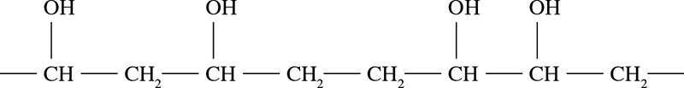

Which of the following monomers could be used to prepare this polymer?

A CH2=CHOH

B CHOH=CHOH

C CH2=CHCH2OH

D CH3CH2OH

6 A particular polymer can be represented by the formula:

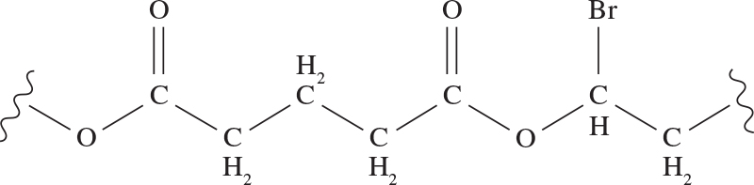

Which of the following pairs of monomers would be required to prepare this polymer?

A HOOCH2CH2CH2COOH and HOCH2CHBrCH2OH

B HOOCCH2CH2CH2OH and HOOCCHBrCH2OH

C HOOCCH2CH2CH2COOH and HOCHBrCH2OH

D HOOCCH2CH2CH2OHand HOCHBrCH2COOH

End of section 1

Section 2: Short answer 31% (13 marks)

This section has 3 questions. Answer all questions. Write your answers in the space provided.

When calculating numerical answers, show your working or reasoning clearly. Express numerical answers to the appropriate number of significant figures and include appropriate units where applicable.

Do not use abbreviations, such as ‘nr’ for ‘no reaction’, without first defining them.

Suggested working time: 14 minutes

____________________________________________________________________________________

Question 7 (4 marks)

The following molecule (M = 118.08 g mol–1) can be used to produce a polymer when it is heated under acidic conditions.

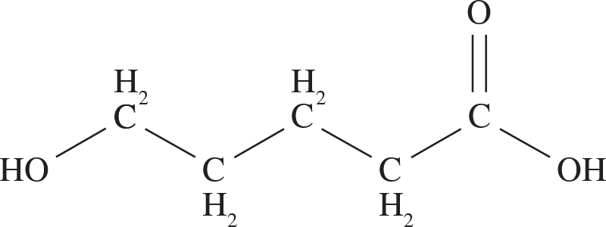

a Draw the structure of the polymer, showing two repeating units. (2 marks)

b What class of polymer is this an example of? (1 mark)

___________________________________________________________________________

c Under these reaction conditions, a small amount of a cyclic compound   
(M = 100.114 g mol–1) was also found to be produced. Draw the structure of this cyclic compound. (1 mark)

Question 8 (6 marks)

Three of the common fatty acids found in mammals are linoleic acid, stearic acid and lauric acid.

|  |  |  |  |
| --- | --- | --- | --- |
|  | Structure | M (g mol–1) | Melting point (°C) |
| Linoleic acid  C18H32O2 |  | 280.45 | –5 |
| Stearic acid  C18H36O2 |  | 284.47 | 69 |
| Lauric acid  C12H24O2 |  | 200.32 | 43 |

a Explain why stearic acid has a higher melting point than lauric acid. (3 marks)

___________________________________________________________________________

___________________________________________________________________________

___________________________________________________________________________

___________________________________________________________________________

___________________________________________________________________________

___________________________________________________________________________

b Hibernating animals possess enzymes called desaturases, which convert saturated fatty acids into unsaturated fatty acids during winter. This lowers the melting point of the fats and prevents them from freezing. Explain why unsaturated linoleic acid has a lower melting point than stearic acid, which is saturated. (3 marks)

___________________________________________________________________________

___________________________________________________________________________

___________________________________________________________________________

___________________________________________________________________________

___________________________________________________________________________

___________________________________________________________________________

Question 9 (3 marks)

Describe three differences between the base catalysed and lipase catalysed methods for the production of biodiesel.

___________________________________________________________________________

___________________________________________________________________________

___________________________________________________________________________

___________________________________________________________________________

___________________________________________________________________________

___________________________________________________________________________

End of section 2

Section 3: Extended answer 40% (17 marks)

This section has 2 questions. Answer both questions. Write your answers in the space provided.

When calculating numerical answers, show your working or reasoning clearly. Express numerical answers to the appropriate number of significant figures and include appropriate units where applicable.

Do not use abbreviations, such as ‘nr’ for ‘no reaction’, without first defining them.

Suggested working time: 19 minutes

____________________________________________________________________________________

Question 10 10 marks

Fats are triglyceride molecules containing three ester groups. They can be used as precursors to produce both soaps and biodiesel. Glycerol is produced as a by-product in both synthetic reactions.

a Write balanced reactions in the space below to show how the tristearin molecule below (a fat) can be used to produce both a soap and biodiesel.

i soap (3 marks)

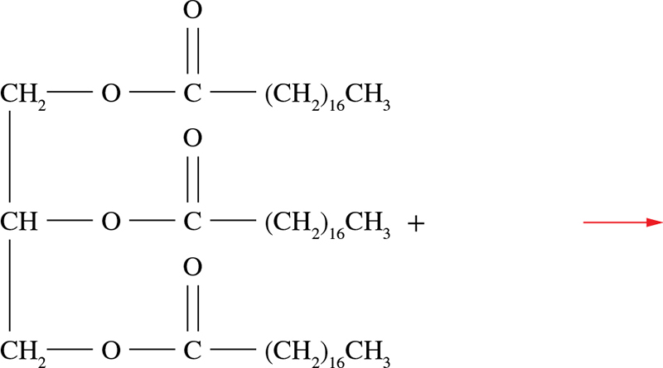

ii biodiesel (3 marks)



b Detergents and soaps share many structural similarities that enable them to act as cleaning agents. Dodecyl sulfate (CH3(CH2)11OSO3–) is a commonly used detergent and its structure is shown below.

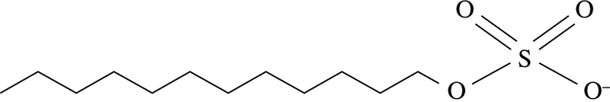

i Discuss the similarities in the structures of soaps and detergents that enable them to remove oil and grease from surfaces (2 marks)

______________________________________________________________________

______________________________________________________________________

______________________________________________________________________

______________________________________________________________________

______________________________________________________________________

______________________________________________________________________

ii Soaps are less effective than detergents when used in hard water. Explain this observation. (2 marks)

______________________________________________________________________

______________________________________________________________________

______________________________________________________________________

______________________________________________________________________

______________________________________________________________________

______________________________________________________________________

Question 11 (7 marks)

Kevlar is a polymer with a high melting point that is used in bulletproof clothing and Formula One car tyres. The diagram below shows two parallel polymer chains.

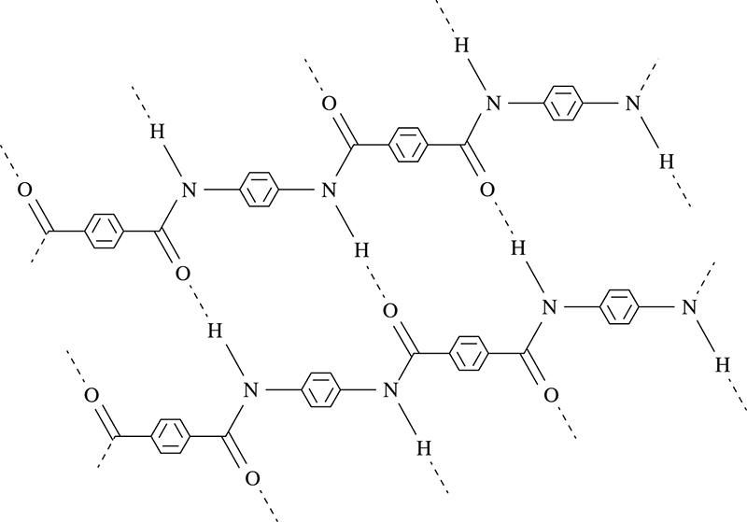

a To what class of polymer does Kevlar belong? (1 mark)

_________________________________________________________________________

b What do the dashed lines on the diagram represent? (1 mark)

_________________________________________________________________________

c Draw the full structures of the monomer(s) from which Kevlar is made. (2 marks)

d Teflon is another polymer that has a relatively high melting point. It is produced from the monomer tetrafluoroethene, shown below.

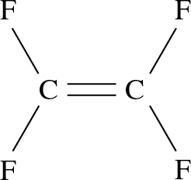

Draw a section of the polymer Teflon, showing at least three repeating units. (2 marks)

e To which class of polymer does Teflon belong? (1 mark)

___________________________________________________________________________

End of questions